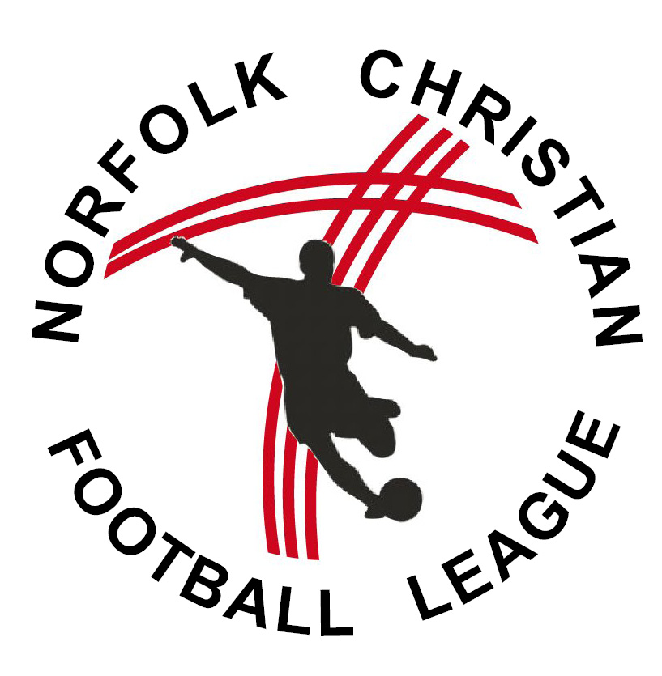
Church Support: 2019/20 Season

I hereby declare to support the club (named below) in their involvement in the Norfolk Christian Football League (NCFL) for the 2019/20 season through prayer, encouragement and Christian oversight.

Church Support – 2019/20
Name:
Club supported:
Name of church/organisation:
Position held:
Address:
Landline Tel:
Mobile:
Email:
Signature:
Details of relationship with club, team managers and support provided
The associated teams of the aforementioned club may play under the name of the church or Christian Organisation of which I am a leader. I am happy to be contacted by the Management Committee of the NCFL if conduct by any individuals of the team is felt to have fallen below the accepted standard or should outstanding debts consistently not be paid.

[ ] The club has its own Constitution, and I have seen a copy (Please tick if applicable)

This form is to be received by the Management Committee before any team is allowed to play in any competition organised by the League. The information supplied above is subject to the Data Protection Act and will be used by the League and the Norfolk County Football Association for administration purposes. It will not be shared with any other party.

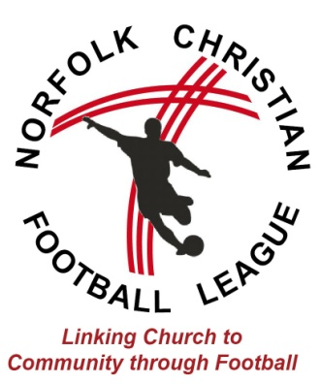
CHURCH SUPPORT FOR THE NORFOLK CHRISTIAN FOOTBALL LEAGUE

The Norfolk Christian League started in the late 1970s, when a small group of churches decided to organise regular competitive football.

Over the years, the league has expanded to include adult teams attracting around 200 players each season and youth leagues from Under 10s to Under 16s attracting over 300 players each season.

The league is currently run by a Management Committee, comprising of members from local churches who seek to link the Church to the community through football. The league is underpinned by regular prayer, following the FA guidance on RESPECT and strong Christian principles. We recognise that many club officials, players and family members may not share in the Christian faith, but seek to link them to local churches to show Christian support.

Guidance for supporting churches

Thank you for considering supporting a club in the Norfolk Christian Football League. There are many ways that the church could support a club, but we believe the minimum requirement should be:-

- For a church leader (or trusted church member) to make regular contact with the management of the team(s), to ensure that Christian principles are being maintained and to continue the link with the church
- For the church to see the football club as part of its outreach ministry and to pray for members of the club.

Other ways of supporting could be:-
- Church members coming to support at matches
- Regular updates in church services or magazines
- Supplying players, officials or referees
- Arranging ‘football-friendly’ events/services to invite the club along to
- Supporting financially.

We believe that playing football can be an expression of faith in God and through developing skills physically, mentally and socially we aim to demonstrate to all connected that a faith in God can play a part in everyday life. Each match starts with a prayer and all players are encouraged to adhere to Christian principles.

